**6**

**Circular Motion and Other Applications of Newton’s Laws**

|  |
| --- |
| **CHAPTER OUTLINE** |

6.1 Extending the Particle in Uniform Circular Motion Model

6.2 Nonuniform Circular Motion

6.3 Motion in Accelerated Frames

6.4 Motion in the Presence of Velocity-Dependent Resistive Forces

* An asterisk indicates a question or problem new to this edition.

|  |
| --- |
| **SOLUTIONS TO THINK-PAIR-SHARE AND ACTIVITIES** |

**\*TP6.1 Conceptualize** If you take the curve too fast, the maximum force of static friction may not be enough to provide the centripetal acceleration of the crate of eggs and it may begin to slip and strike the side of the pickup. If you hit the brakes, the crate of eggs might start sliding forward and hit the front of the bed of the truck. What should you do?

**Categorize** If you go around the curve, the crate of eggs is modeled as a *particle in uniform circular motion.* If you hit the brakes, the crate is modeled as a *particle under a net force.* Let’s assume that the acceleration during braking is constant.

**Analyze** Let’s first convert the speed to metric units so we have all values in consistent units:



(i) If the truck goes around the curve, the particle in uniform circular motion model gives us



If the force of static friction is at its maximum value, this equation will give us the highest speed at which the truck can take the curve without the crate slipping. From the particle in equilibrium model in the vertical direction, the normal force on the crate is equal to its weight. Therefore,



Substitute numerical values:

 (1)

Your speed of 20.1 m/s is much higher than this, so you clearly do not want to continue around the curve at your initial speed.

(ii) Let’s apply enough braking pressure to the pedal to stop in the distance of 15.0 m, so that we do not enter the curve. Modeling the crate as a particle under a net force, with the only force in the horizontal direction being that due to the friction force,



Let’s suppose you are slowing down at the maximum magnitude of acceleration possible such that the crate does not slip. Then we can replace the friction force with *–sn* (the friction force is toward the back of the truck to keep the eggs from sliding forward):



Substituting numerical values:

 (2)

Any acceleration of magnitude larger than 5.88 m/s2 will cause the eggs to slide. Now model the crate as a particle under constant acceleration and find the acceleration necessary to reduce the speed of the crate to zero. From Equation 2.17,

 (3)

Substitute numerical values:

 (4)

The magnitude of acceleration in Equation (4) required to stop is larger than the maximum value found in Equation (2), so the eggs will slip as you slow down if you try this.

(iii) Suppose you want to slow down just enough so you enter the curve at the maximum speed for the curve found above in (i). Then Equation (3) becomes

 (5)

Substitute numerical values:



This value is still larger in magnitude than the safe acceleration in Equation (2).

**Finalize** Therefore, *none* of the suggested actions can help. There is nothing you can do; the eggs are doomed! Pay more attention!

*Answer:* None of the options can save the eggs.

**\*TP6.2** *Answers:* (a) Typical periods will be about 4 s and typical radii will be about 7–8 m, leading to centripetal accelerations ranging from about 17 to 20 m/s2. (b) The centripetal acceleration of a rider at the top of the ride is larger than that due to gravity, *g* = 9.80 m/s2. (c) Because the centripetal acceleration of the wall behind the rider is larger than that due to gravity, the wall actually pushes downward with a normal force on the rider. The rider is accelerating downward at that point faster than he would if simply falling.

**\*TP6.3** Typical periods will be about 2 s and typical radii will be about 5 m. The minimal static friction force between the wall and a rider must just balance the weight of a rider: *fs* = *mg*. Furthermore, the normal force inward from the wall must provide the centripetal acceleration: *n* = *mr*2. Combining these equations, using *fs* = *sn*, we find that . Using typical values, the minimum coefficient of static friction should come out to be about 0.2. A coefficient larger than this value can easily be attained by covering the walls of the ride with rough-textured cloth.

*Answer:* ~ 0.2

|  |
| --- |
| **SOLUTIONS TO END-OF-CHAPTER PROBLEMS** |

Section 6.1 Extending the Particle in Uniform Circular Motion Model

**P6.1** (a) The force acting on the electron in the Bohr model of the hydrogen atom is directed radially inward and is equal to



(b)



**P6.2** (a) The astronaut’s orbital speed is found from Newton’s second law, with

 

solving for the velocity gives



(b) To find the period, we use  and solve for *T*:



**P6.3** (a) The car’s speed around the curve is found from



This is the answer to part (b) of this problem. We calculate the radius of the curve from  which gives *r* = 150 m. The car’s acceleration at point *B* is then



(b) From part (a), 

(c) We find the average acceleration from



**P6.4** In  both *m* and *r* are unknown but remain constant. Symbolically, write

 and 

Therefore,  is proportional to *v*2 and increases by a factor of  as *v* increases from 14.0 m/s to 18.0 m/s. The total force at the higher speed is then



This force must be  to produce the driver’s centripetal acceleration.

**P6.5** We neglecting relativistic effects. With 1 u = 1.661 x 10–27 kg, and from Newton’s second law, we obtain



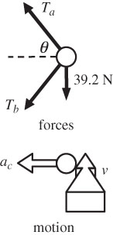**P6.6** We solve for the tensions in the two strings:



The angle  is given by



The radius of the circle is then

**ANS. FIG. P6.6**



Applying Newton’s second law,

 **[1]**

 **[2]**

To solve simultaneously, we add the equations in *Ta* and *Tb*:

(*Ta* + *Tb*) + (*Ta* – *Tb*) = 41.2 N + 52.3 N



This means that *Tb* = 41.2 N – *Ta* = –5.7 N, which we may interpret as meaning the lower string pushes rather than pulls!



To answer the **What if?**, we go back to equation [2] above and substitute *mg* for the weight of the object. Then,



We then add this equation to equation [2] to obtain

(*Ta* + *Tb*) + (*Ta* – *Tb*) = 41.2 N + 5.33*g*

or 

For this situation to be possible, *Tb* must be > 0, or *g* < 7.72 m/s2. This is certainly the case on the surface of the Moon and on Mars.

**\*P6.7** **Conceptualize** You may have been on this ride and may be familiar with the situation. Figure P6.5 shows a rider on the ride. The rider is moving in a circular path, along with the section of wall just behind her.

**Categorize** Consider a time interval during which the rotation speed of the ride is constant. Then the rider can be modeled as a *particle under a net force* and a *particle in uniform circular motion* in the horizontal direction, and a *particle in equilibrium* in the vertical direction.

**Analyze** A free-body diagram for the rider appears below.

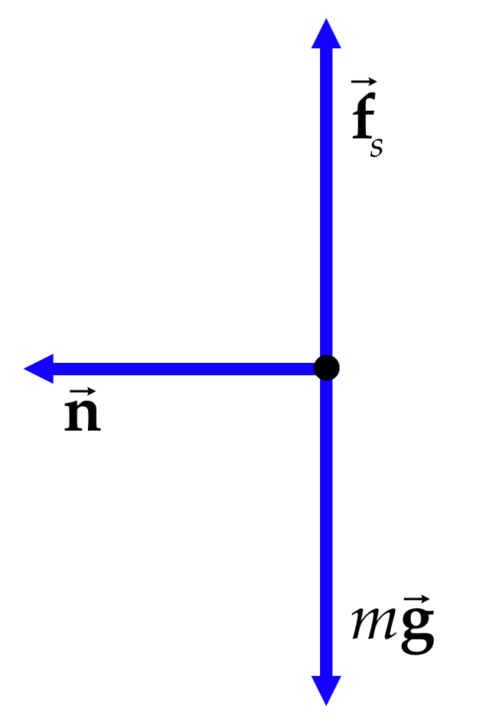

Apply the particle in equilibrium model in the vertical direction:

 (1)

Apply the particle under a net force model in the horizontal direction, with the acceleration being centripetal:

 (2)

Divide equation (2) by Equation (1):

 (3)

Let us consider the limiting case in which the ride is rotating at the right angular speed to just keep the rider pinned to the wall. If the ride were to operate just a bit more slowly, the rider would begin to slide downward. Therefore, we are looking at the situation of impending motion for static friction, so that

 (4)

Substituting Equation (4) into Equation (3) and solving for *v* gives

 (5)

We wish to find the angular speed, so let us evaluate this parameter. From Equation 4.24, and using Equation (5), we find

 (6)

(a) Now, what if the heavy person enters the ride? The mass *m* of the person does not appear in Equation (6), so the desired angular speed is independent of the mass of the person. You do not have to change the speed of the ride.

(b) How about the person wearing the slippery satin workout outfit? The slippery outfit results in a lower coefficient of friction between the outfit and the wall. In Equation (6), we see that reducing the coefficient of friction increases the minimum angular speed to keep the person pinned to the wall. Therefore, the ride must be spun faster.

**Finalize** In practice, the interior wall of the cylinder is lined with a rough material to minimize any effects of variations in clothing, and the ride is spun with a significantly higher angular speed than that found numerically from Equation (6).

*Answers:* (a) no (b) yes

**\*P6.8 Conceptualize** In Example 6.7, we determined that a pendulum can be used as an accelerometer.Try running along a straight line while hanging an object on a string from your finger as a pendulum. If you accelerate in the forward direction, the pendulum will deviate backward. The faster you accelerate, the larger is the angle of deviation. In the opening storyline for this chapter, we used a pendulum to exhibit the existence of centripetal acceleration on the Mad Tea Party ride. For our car rounding a curve on the freeway in this problem, we will see the pendulum deviating toward the outside of the curve, opposite to the direction of the centripetal acceleration of the pendulum bob.

**Categorize** The pendulum bob can be modeled as a *particle under a net force* and a *particle in uniform circular motion* in the horizontal direction, and a *particle in equilibrium* in the vertical direction.

**Analyze** A free-body diagram for the pendulum bob appears below, looking along the direction of travel of the car.

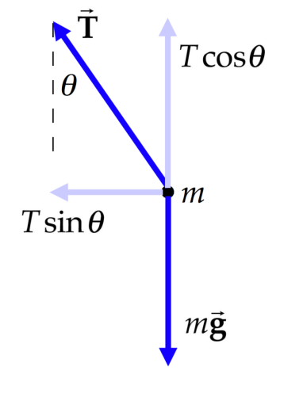

Apply the particle in equilibrium model in the vertical direction:

 (1)

Apply the particle under a net force model in the horizontal direction, with the acceleration being centripetal:

 (2)

where *v* is the speed of the car and, therefore, of the pendulum bob, and *r* is the radius of the circular path of the pendulum bob and, therefore, the radius of curvature of the roadway. Divide Equation (2) by Equation (1) and solve for *r*:

 (3)

Substitute the numerical values given in the experiment:



**Finalize** The radius of curvature is 34% larger than the state regulation, so you

can testify that the curve was *not* too tight for the driver to negotiate at

65 mi/h. The accident must have been caused by something else.

*Answer:* The radius of curvature is larger than 150 m, so the driver is not justified in his claim as to faulty design of the roadway.

**Section 6.2 Non uniform Circular Motion**

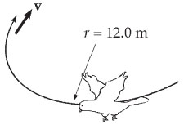**P6.9** (a) The hawk’s centripetal acceleration is



(b) The magnitude of the acceleration vector is

**ANS. FIG. P6.9**



at an angle



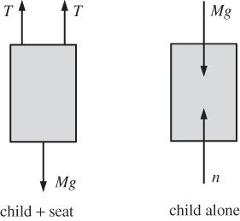**P6.10** We first draw a force diagram that shows the forces acting on the child-seat system and apply Newton’s second law to solve the problem. The child’s path is an arc of a circle, since the top ends of the chains are fixed. Then at the lowest point the child’s motion is changing in direction: He moves with centripetal acceleration even as his speed is not changing and his tangential acceleration is zero.

**ANS. FIG. P6.10**

(a) ANS. FIG. P6.10 shows that the only forces acting on the system of child + seat are the tensions in the two chains and the weight of the boy:



with 

solving for *v* gives



(b) The normal force from the seat on the child accelerates the child in the same way that the total tension in the chain accelerates the child-seat system. Therefore, .

**P6.11** See the forces acting on seat (child) in ANS. FIG. P6.10.

(a) 





(b) 



P6.12 (a) Consider radial forces on the object, taking inward as positive.



Solving for the tension gives



(b) We already found the radial component of acceleration,



Consider the tangential forces on the object:



Solving for the tangential component of acceleration gives



(c) The magnitude of the acceleration is



at an angle of



Thus, the acceleration is



(d) 

(e) 

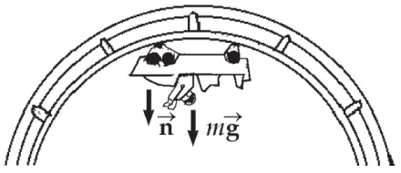**P6.13** (a) 



**ANS. FIG. P6.13**

(b) Let *n* be the force exerted by the rail.

Newton’s second law gives





(c) , or 

(d) If the force exerted by the rail is *n*1,

then 

 which is < 0 since *ac* = 8.45 m/s2





**Section 6.3 Motion in Accelerated Frames**

**P6.14** (a) From  we obtain

 to the right

(b) If *v* = const, *a =* 0, so  (This is also an equilibrium situation.)

(c) 

(d) 

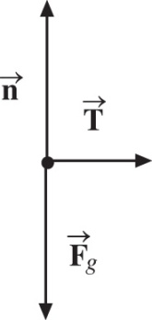

ans. Fig. P6.14

**P6.15** The scale reads the upward normal force exerted by the floor on the passenger. The maximum force occurs during upward acceleration (when starting an upward trip or ending a downward trip). The minimum normal force occurs with downward acceleration. For each respective situation,

 becomes for starting +591 N − *mg* = +*ma*

and for stopping +391 N − *mg* = −*ma*

where *a* represents the magnitude of the acceleration.

(a) These two simultaneous equations can be added to eliminate *a* and solve for *mg*:

+ 591 N − *mg* + 391 N − *mg* = 0

or 982 N – 2*mg* = 0



(b) From the definition of weight, 

(c) Substituting back gives +591 N − 491 N = (50.1 kg)*a*, or



**P6.16** Consider forces on the backpack as it slides in the Earth frame of reference.



The motion across the floor is described by



We solve for 





**P6.17** The water moves at speed



The top layer of water feels a downward force of gravity *mg* and an outward fictitious force in the turntable frame of reference,



It behaves as if it were stationary in a gravity field pointing downward and outward at



Its surface slopes upward toward the outside, making this angle with the horizontal.

**Section 6.4 Motion in the Presence of Resistive Forces**

**P6.18** With 100 km/h = 27.8 m/s, the resistive force is



**P6.19** (a) Since the window is vertical, the normal force is horizontal and is given by *n* = 4.00 N. To find the vertical component of the force, we note that the force of kinetic friction is given by

*fk* = *µkn* = 0.900(4.00 N) = 3.60 N upward

to oppose downward motion. Newton’s second law then becomes



(b) Now, with the increased downward force, Newton’s second law gives



then



(c) At terminal velocity,



Solving for the terminal velocity gives



**P6.20** (a) The acceleration of the Styrofoam is given by

*a* = *g* – *Bv*

When *v* = *vT*, *a* = 0 and 

The Styrofoam falls 1.50 m at constant speed *vT* in 5.00 s.

Thus,



Then



(b) At *t* = 0, *v* = 0, and 

(c) When *v* = 0.150 m/s,



**P6.21** We have a particle under a net force in the special case of a resistive force proportional to speed, and also under the influence of the gravitational force.

(a) The speed *v* varies with time according to Equation 6.6,



where *vT* = *mg*/*b* is the terminal speed. Hence,



(b) To find the time interval for *v* to reach 0.632*vT*, we substitute   
*v* = 0.632*vT* into Equation 6.6, giving

0.632*vT* = *vT* (1 − *e*−*bt*/*m*) or 0.368 = *e*−(1.47*t*/0.003 00)

Solve for *t* by taking the natural logarithm of each side of the equation:



or 

(c) At terminal speed, *R* = *vTb* = *mg.* Therefore,



**P6.22** We start with Newton’s second law,



substituting,



integrating both sides gives



**P6.23** In , we estimate that the coefficient of drag for an open palm is *D* = 1.00, the density of air is  the area of an open palm is  and *v* = 29.0 m/s (65 miles per hour). The resistance force is then



or 

**Additional Problems**

**P6.24** Because the car travels at a constant speed, it has no tangential acceleration, but it does have centripetal acceleration because it travels along a circular arc. The direction of the centripetal acceleration is toward the center of curvature, and the direction of velocity is tangent to the curve.

Point A

direction of velocity: 

direction of the centripetal acceleration: 

Point B

direction of velocity: 

direction of the centripetal acceleration: 

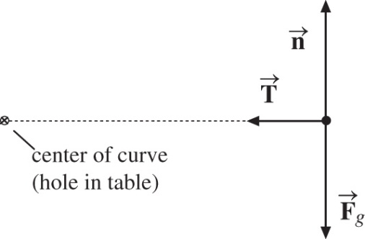**P6.25** The free-body diagram of the rock is   
shown in ANS. FIG. P6.25. Take the   
*x* direction inward toward the center   
of the circle. The mass of the rock   
does not change. We know when   
*r*1 = 2.50 m, *v*1 = 20.4 m/s, and   
*T*1 = 50.0 N. To find *T*2 when   
*r*2 = 1.00 m, and *v*2 = 51.0 m/s, we  
use Newton’s second law in the   
horizontal direction:

**ANS. FIG. P6.25**



In both cases,

 and 

Taking the ratio of the two tensions gives



then



We assume the tension in the string is not altered by friction from the hole in the table.

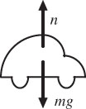**P6.26** (a) We first convert the speed of the car to SI units:



**ANS. FIG. P6.26**

Newton’s second law in the vertical direction  
then gives

 

Solving for the normal force,



(b) At the maximum speed, the weight of the car is just enough to provide the centripetal force, so *n* = 0. Then  and



**P6.27** (a) The free-body diagram in ANS. FIG. P6.26 shows the forces on the car in the vertical direction. Newton’s second law then gives



 

(b) When *n* = 0, 

Then, 

A more gently curved bump, with larger radius, allows the car to have a higher speed without leaving the road. This speed is proportional to the square root of the radius.

**P6.28**  The free-body diagram for the object is shown in ANS. FIG. P6.28. The object travels in a circle of radius *r* = *L* cos *θ* about the vertical rod.

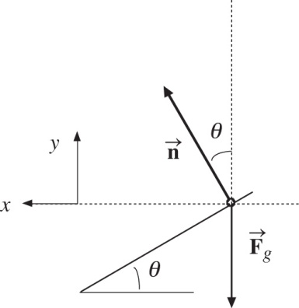 Taking inward toward the center of the circle as the positive *x* direction, we have

 





Dividing, we find

ans. Fig. P6.28



Solving for *v* gives



**P6.29**  Let *vi* represent the speed of the object at time 0. We have



From its original value, the speed decreases rapidly at first and then more and more slowly, asymptotically approaching zero.



The distance it travels is given by





As *t* goes to infinity, the distance approaches 

**P6.30** The radius of the path of object 1 is twice that of object 2. Because the strings are always “collinear,” both objects take the same time interval to travel around their respective circles; therefore, the speed of object 1 is twice that of object 2.

The free-body diagrams are shown in ANS. FIG. P6.30. We are given *m*1= 4.00 kg, *m*2 = 3.00 kg,   
*v* = 4.00 m/s, and 

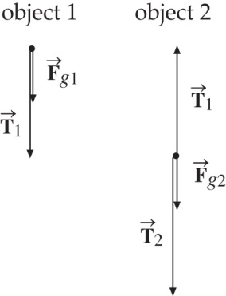 Taking down as the positive direction, we have

Object 1: , where *v*1 = 2*v*, 

Object 2: , where *v*2 = *v*, 

ans. Fig. P6.30

(a) From above:







(b) From above:







*T*2 = 216.8 N + 66.6 N = 283.4 N = 

(c) 

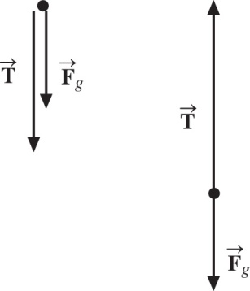**P6.31** (a) At each point on the vertical circular path, two forces are acting on the ball (see ANS. FIG. P6.31):

(1)  with constant magnitude *Fg* = *mg*

(2) 

ans. Fig. P6.31

(b) ANS. FIG. P6.31 shows the forces acting on the ball when it is at the highest point on the path (left-hand diagram) and when it is at the bottom of the circular path (right-hand diagram). Note that the gravitational force has the same magnitude and direction at each point on the circular path. The tension force varies in magnitude at different points and is always directed toward the center of the path.

(c) At the top of the circle, *Fc* = *mv*2/*r* = *T* + *Fg*, or



(d) At the bottom of the circle, *Fc* = *mv*2/*r* = *T* – *Fg* = *T* – *mg*, and solving for the speed gives

 and 

If the string is at the breaking point at the bottom of the circle, then *T* = 22.5 N, and the speed of the object at this point must be

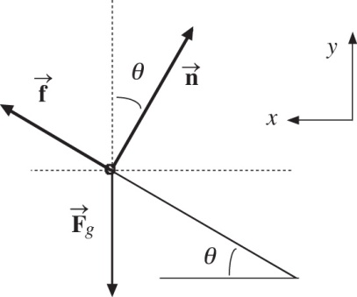 

**P6.32**  The free-body diagram is shown on the right, where it is assumed that friction points up the incline, otherwise, the child would slide down the incline. The net force is directed left toward the center of the circular path in which the child travels. The radius of this path is 

**ANS. FIG. P6.46**

Three forces act on the child, a normal force, static friction, and gravity. The relations of their force components are:

 **[1]**

 [2]

Solve for the static friction and normal force.

To solve for static friction, multiply equation [1] by cos *θ* and equation [2] by sin *θ* and add:





To solve for the normal force, multiply equation [1] by –sin *θ* and equation [2] by cos *θ* and add:





In the above, we have used 

If the above equations are to be consistent, static friction and the normal force must satisfy the condition *fs* ≤ *µsn*; this means



Using this result, and that *R* = *d* cos *θ*, we have the requirement that



If this condition cannot be met, if *v* is too large, the physical situation cannot exist.

The values given in the problem are *d* = 5.32 m, *µs* = 0.700, *θ* = 20.0°, and *v* = 3.75 m/s. Check whether the given value of *v* satisfies the above condition:





**P6.33** (a) We first convert miles per hour to feet per second:

 at the top of the loop and *v* = 450 mi/h = 660 ft/s at the bottom of the loop.

At the lowest point, his seat exerts an upward force; therefore, his weight seems to increase. His apparent weight is



(b) At the highest point, the force of the seat on the pilot is directed down and



Since the plane is upside down, the seat exerts this downward force as a normal force.

(c) 

**P6.34** (a) The forces acting on the ice cube are the Earth’s gravitational force, straight down, and the basin’s normal force, upward and inward at 35.0° with the vertical. We choose the *x* and *y* axes to be horizontal and vertical, so that the acceleration is purely in the *x* direction. Then





Dividing eliminates the normal force:



tan 35.0° = *v*2/*Rg*



(b) 

(c) The answer to (a) indicates that the speed is proportional to the square root of the radius, so  

(d) The period of revolution is given by





(e) 

**P6.35** (a) 

(b) From Newton’s second law in one dimension,



solving for the stopping distance gives



(c) Newton’s second law now gives



or 

A top view shows that you can avoid running into the wall by turning through a quarter-circle, if you start at least this far away from the wall.

(d) 

(e) 

**P6.36** Take the positive *x* axis up the hill. Newton’s second law in the *x* direction then gives



from which we obtain

 **[1]**

In the *y* direction,



Solving for the tension gives

 **[2]**

Substituting for *T* from [2] into [1] gives



**P6.37** (a) The gravitational force exerted by the planet on

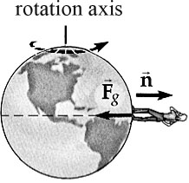

ANS. FIG. P6.37

the person is

*mg* = (75.0 kg)(9.80 m/s2)

= down

Let *n* represent the force exerted on the person by a scale, which is an upward force whose size is her “apparent weight.” The true weight is *mg* down. For the person at the equator, summing up forces on the object in the direction towards the Earth’s center gives 

*mg* − *n* = *mac*

where *ac* = *v*2/*RE* = 0.033 7 m/s2

is the centripetal acceleration directed toward the center of the Earth.

Thus, we can solve part (c) before part (b) by noting that

*n* = *m*(*g* − *ac*) < *mg*

(c) or *mg* = *n + mac* > *n.*



(b) If *m* = 75.0 kg and *g* = 9.80 m/s2, at the equator we have

*n* = *m*(*g* − *ac*) = (75.0 kg)(9.800 m/s2 – 0.033 7 m/s2) = 

**P6.38** (a) Since the object of mass *m*2 is in equilibrium, 

or .

(b) The tension in the string provides the required centripetal acceleration of the puck.

Thus, .

(c) From ,

we have 

(d)  It gains speed because the extra-large string tension pulls at an angle of less than 90° to the direction of the inward-spiraling velocity, producing forward tangential acceleration as well as inward radial acceleration of the puck.

(e) 

**P6.39** (a) *v* = *vi* + *kx* implies the acceleration is



(b) The total force is



As a vector, the force is parallel or antiparallel to the velocity:



(c) 

(d) 

**P6.40** (a)

|  |  |  |  |
| --- | --- | --- | --- |
| *t*(s) | *d* *(*m*)* | *t*(s) | *d* *(*m*)* |
| 1.00 | 4.88 | 11.0 | 399 |
| 2.00 | 18.9 | 12.0 | 452 |
| 3.00 | 42.1 | 13.0 | 505 |
| 4.00 | 43.8 | 14.0 | 558 |
| 5.00 | 112 | 15.0 | 611 |
| 6.00 | 154 | 16.0 | 664 |
| 7.00 | 199 | 17.0 | 717 |
| 8.00 | 246 | 18.0 | 770 |
| 9.00 | 296 | 19.0 | 823 |
| 10.0 | 347 | 20.0 | 876 |

(b)  
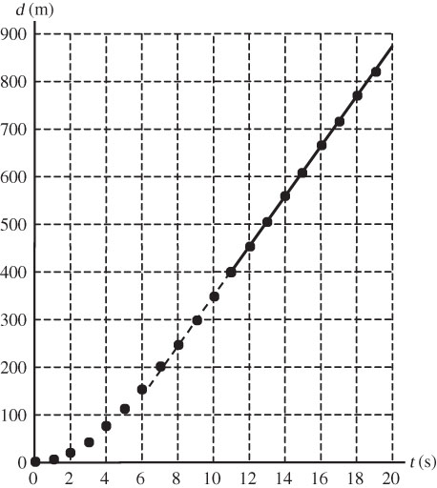

(c) A straight line fits the points from *t* = 11.0 s to 20.0 s quite precisely. Its slope is the terminal speed.



**P6.41** (a) If the car is about to slip *down* the incline, *f* is directed up the 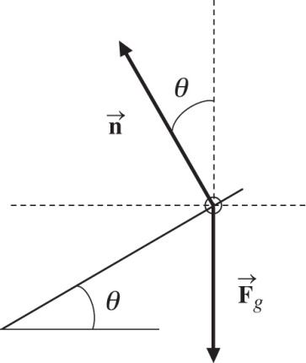incline.



where  Substituting,



and 

**ANS. FIG. P6.41**

Then,  yields



When the car is about to slip *up* the incline, *f* is directed down the incline. Then,

 with 

This yields

 and 

In this case, , which gives



(b) If , then .

**P6.42** There are three forces on the child, a vertical normal force, a horizontal force (combination of friction and a horizontal force from a seat belt), and gravity.

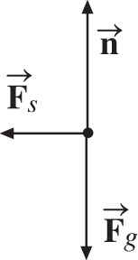 



The magnitude of the net force is



**ANS. FIG. P6.42**

with a direction of

 above the horizontal

For *m* = 40.0 kg and *R* = 10.0 m:





direction: 

**P6.43** (a) The putty, when dislodged, rises and returns to the original level in time *t*. To find *t*, we use *vf* = *vi* + *at*: i.e., –*v* = + *v* – *gt* or  where *v* is the speed of a point on the rim of the wheel.

If *R* is the radius of the wheel, , so .

Thus, 

(b) The putty is dislodged when *F*, the force holding it to the wheel, is



**P6.44** The plane’s acceleration is toward the center of the circle of motion, so it is horizontal. The radius of the circle of motion is (60.0 m) cos 20.0° = 56.4 m and the acceleration is

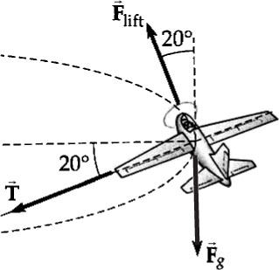

ANS. FIG. P6.44



We can also calculate the weight of the airplane:

*Fg* = *mg*

= (0.750 kg)(9.80 m/s2)

= 7.35 N

We define our axes for convenience. In this case, two of the forces—one of them our force of interest—are directed along the 20.0° line. We define the *x* axis to be directed in the  direction, and the *y* axis to be directed in the direction of lift. With these definitions, the *x* component of the centripetal acceleration is

*acx* = *ac* cos 20.0°

and  *max* yields *T + Fg* sin 20.0° = *macx*

Solving for *T*,

*T* = *macx* − *Fg* sin 20.0°

Substituting,

*T* = (0.750 kg)(21.7 m/s2) cos 20.0° − (7.35 N) sin 20.0°

Computing,

*T* = 15.3 N − 2.51 N = 

**Challenge Problems**

**P6.45** We find the terminal speed from

 **[1]**

where exp(*x*) = *ex* is the exponential function.

At  

At *t* = 5.54 s: 

Solving,



(a) From , we have



(b) We substitute 0.750*v*T on the left-hand side of equation [1]:



and solve for *t*:





(c) We differentiate equation [1] with respect to time,



then, integrate both sides





At *t* = 5.54 s,



**P6.46** (a) From Problem 6.33,



(b) We have 



**P6.47** Let the *x* axis point eastward, the *y* axis upward, and the *z* axis point southward.

(a) The range is 

The initial speed of the ball is therefore



The time the ball is in the air is found from  as



giving .

(b) 

(c) 360° of latitude corresponds to a distance of , so 285 m is a change in latitude of



The final latitude is then



The cup is moving eastward at a speed



which is larger than the eastward velocity of the tee by



Since  is such a small angle,  and





(d) 

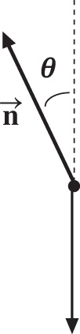**P6.48** (a) We let *R* represent the radius of the hoop and *T* represent the period of its rotation. The bead moves in a circle with radius  at a speed of



The normal force has an inward radial   
component of *n*sin*θ* and an upward component   
of *n*cos*θ .*



ANS. FIG. P6.48

or



Then  becomes 

which reduces to 

This has two solutions:  **[1]**

and  **[2]**

If *R* = 15.0 cm and *T* = 0.450 s, the second solution yields

 or *θ* = 70.4°

Thus, in this case, the bead can ride at two positions:  and .

(b) At this slower rotation, solution [2] above becomes

, which is impossible.

In this case, the bead can ride only at the bottom of the loop, .

(c) 

(d) 

(e) 

**P6.49** At a latitude of 35°, the centripetal acceleration of a plumb bob is directed at 35° to the local normal, as can be seen from the following diagram below at left.

Therefore, if we look at a diagram of the forces on the plumb bob and its acceleration with the local normal in a vertical orientation, we see the second diagram in ANS. FIG. P6.49:

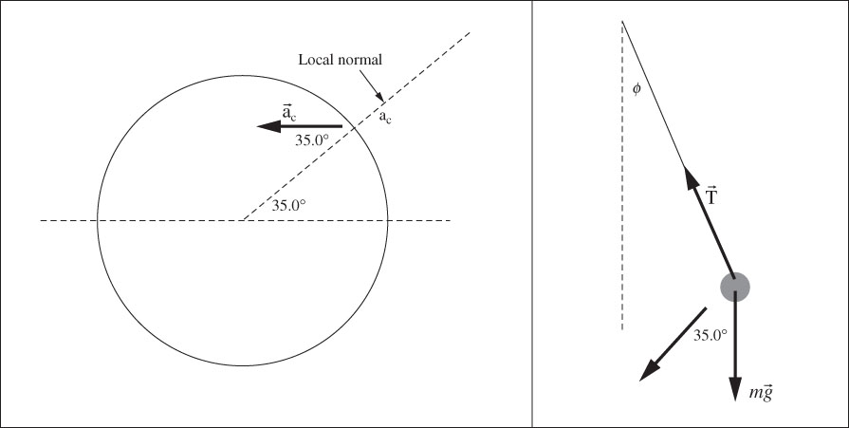

ans. Fig. P6.49

We first find the centripetal acceleration of the plumb bob. The first figure shows that the radius of the circular path of the plumb bob is   
*R* cos 35.0°, where *R* is the radius of the Earth. The acceleration is



Apply the particle under a net force model to the plumb bob in both *x* and *y* directions in the second diagram:



Divide the equations:







**\*P6.50 Conceptualize** The ball is moving through air, so the resistive force will cause it to slow down as it approaches home plate. This is very hard to see in the short time interval between the pitcher’s mound and home plate, but it does happen.

**Categorize** Because the speed of the baseball through the air is high, we use Equation 6.7 to characterize the resistive force on the baseball. As the ball moves through the air, it is modeled as a *particle under a net force,* where the net force varies in time, because it varies with speed.

**Analyze** Using Newton’s second law, with the resistive force on the baseball described by Equation 6.7, we have

 (1)

Solve Equation (1) for *a*:

 (2)

where we have defined *k* as

 (3)

Now, let’s express *a* as a derivative and use the chain rule as suggested in the Hint:

 (4)

Rearrange the differential equation and integrate:

 (5)

Considering Equation 6.10, we recognize the parameters that form the value of *k* as appearing in the expression for the terminal speed:

 (6)

Therefore, *k* is given by

 (7)

The equation for the speed of the baseball at any time, then, can be expressed as

 (8)

Substitute numerical values, using the terminal velocity found in Table 6.1:



**Finalize** We were able to simplify this problem because we have the terminal speed of a baseball given in Table 6.1. If we didn’t have that value, we could express Equation (5) as



This equation would also work, but we would need to determine the density of

air as well as parameters associated with the baseball: its drag coefficient, mass,

and cross-sectional area

*Answer:* 36.5 m/s

|  |
| --- |
| **ANSWERS TO QUICK-QUIZZES** |

**1. (i)** (a) **(ii)** (b)

**2. (i)** Because the speed is constant, the only direction the force can have is that of the centripetal acceleration. The force is larger at Ⓒ than at Ⓐ because the radius at Ⓒ is smaller. There is no force at Ⓑ because the wire is straight. **(ii)** In addition to the forces in the centripetal direction in part (a), there are now tangential forces to provide the tangential acceleration. The tangential force is the same at all three points because the tangential acceleration is constant.

**3.** (c)

**4.** (a)

|  |
| --- |
| **ANSWERS TO EVEN-NUMBERED PROBLEMS** |

**P6.2** (a) 1.65 × 103 m/s; (b) 6.84 × 103 s

**P6.4** 215 N, horizontally inward

**P6.6** The situation is impossible because the speed of the object is too small, requiring that the lower string act like a rod and push rather than like a string and pull.

**P6.8** The radius of curvature is larger than 150 m, so the driver is not justified in his claim as to faulty design of the roadway.

**P6.10** (a) 4.81 m/s; (b) 700 N

**P6.12** (a) 20.6 N; (b) 32.0 m/s2 inward, 3.35 m/s2 downward tangent to the circle; (c) 32.2 m/s2 inward and below the cord at 5.98˚; (d) no change; (e) acceleration is regardless of the direction of swing

**P6.14** (a) 3.60 m/s2; (b) T = 0; (c) noninertial observer in the car claims that the forces on the mass along x are T and a fictitious force (−Ma); (d) inertial observer outside the car claims that T is the only force on M in the x direction

**P6.16** 

**P6.18** 0.212 m/s2, opposite the velocity vector

**P6.20** (a) 32.7 s–1; (b) 9.80 m/s2 down; (c) 4.90 m/s2 down

**P6.22** (a) 1975 lb (b) -647 lb

(c) When Fg’= 0, then mg =mv2/R. If we vary the aircraft’s R and *v* such that this equation is satisified, then the pilot feels weightless.

**P6.24** (a) At A, the velocity is eastward and the acceleration is southward.

(b) At B, the velocity is southward and the acceleration is westward.

**P6.26** (a) 1.15 × 104 N up; (b) 14.1 m/s

**P6.28** See Problem 6.28 for full derivation.

**P6.30** (a) 217 N; (b) 283 N; (c) T2 > T1 always, so string 2 will break first

**P6.32** The situation is impossible because the speed of the child given in the problem is too large: static friction could not keep the child in place on the incline

**P6.34** (a) ; (b) the mass is unnecessary;   
(c) increasing the radius will make the required speed increase; (d) when the radius increases, the period increases; (e) the time interval required is proportional to 

**P6.36** *g*(cos φ tan θ- 2 sin φ)

**P6.38** (a) m2g; (b) m2g; (c) ; (d) The puck will spiral inward, gaining speed as it does so; (e) The puck will spiral outward, slowing down as it does so

**P6.40** (a) See table in P6.40 (a); (b) See graph in P6.60 (b); (c) 53.0 m/s

**P6.42** 84.7°

**P6.44** 12.8 N

**P6.46** (a) ; (b) 

**P6.48** (a)  = 70.4° and  = 0°; (b)  = 0°; (c) the period is too large; (d) Zero is always a solution for the angle; (e) there are never more than two solutions

**P6.50** 36.5 m/s